APG5782 - SEE film festival group report

5782 Film Festival Report
Group Number: Group 1

Group Member:
Shannon Pudney - Festival director
Xinyi Duan (Ava) - Marketing officer
Yanxiao Lyu (Addie) - Logistics officer
Yue She (Shay) - Financial director
Zhengrong Wang (Rare) - Film programmer
Word Count: 2543 (excluding the title page and the references page)

Tutor: Aimee Traficante

Tutorial time: Thursday, 11:00 - 14:00

Link to promotional materials
https://docs.google.com/presentation/d/1YGHjxfEEuUuyjpX4X6EUUL_ZnZI-IdUq7f9hBEU8hME/edit?usp=sharing

Brochure’s link :
https://www.canva.com/design/DAGx0NJkMyY/_LGlDG4tnEtyNrSAhsQ4-A/edit?utm_content=DAGx0NJkMyY&utm_campaign=designshare&utm_medium=link2&utm_source=sharebutton

Audio’s link:
https://www.canva.com/design/DAGyvGeBjGk/ti4t5aPOc1rn8ybOHdKN-A/edit?utm_content=DAGyvGeBjGk&utm_campaign=designshare&utm_medium=link2&utm_source=sharebutton

Description (of aim, scope and vision)
The SEE Film Festival is a four-day celebration of cinema, built with a passion for making films accessible to blind and low-vision audiences. As vision-impaired journalist Richard Kakol (2021) stated: “most people have no idea how a person who is blind experiences a film”. For many, cinema visits can be challenging due to the limited use of accessible technologies like Audio Description (AD) and a lack of staff knowledge about these aids. The SEE Film Festival was created to bridge this gap and to reimagine film festivals as inclusive spaces where everyone can share in the joy of cinema and the festival experience.
Across its four days, the festival explores different facets of film through themed programs, such as soundscapes, blockbusters, classic musicals, and documentaries featuring blind representation. Alongside screenings, the festival has a rich program of activities including immersive sound films, Q&As with filmmakers, and interactive sensory exhibits and installations. The aim of the SEE festival is to enhance the film experience for blind and low-vision audiences through audio description and sound-centred storytelling, while also inviting sighted audiences to rethink the act of movie-watching as not “just a visual activity” (Kakol 2021) but as one deeply rooted in sound.
Our vision is also to do good in more areas than one. As a not-for-profit initiative, all ticket proceeds from the festival are donated to Vision Australia, directly supporting research into blindness and low vision, as well as programs that empower affected individuals in education, culture, and daily life. Through the festival, we aim to raise public awareness of accessibility in cultural events like festivals, foster inclusive participation in even the simple pleasures like movie-watching, and strengthen community ties.
Ultimately, the SEE Film Festival is more than just a film festival, it is a collective cultural experience where cinema truly belongs to everyone.

Festival films shown (with director and year)

Day | Theme | Films
1 | Soundscape (audio focused) | - Touch (Christopher Houghton, 2024)  - Dusk Chorus (Alessandro D'Emilia and Nika Saravanja, 2017)  - Soundscape (Timmy O'Neill, 2023)  - Le Brasier Shelley (Ludovic Chavarot and Céline Ters, 2018)
2 | Blockbusters | - Frozen (Jennifer Lee and Chris Buck, 2013)  - Mama Mia! (Phyllida Lloyd, 2008)  - The Lion King (Rob Minkoff and Roger Allers, 1994)  - La la land (Damien Chazelle, 2016)
3 | Classic musicals | - The Sound of Music (Robert Wise,1965)  - Hamilton (Thomas Kail, 2020)  - Grease (Randal Kleiser, 1978)  - Les Miserables (Tom Hooper, 2012)
4 | Representation in film | - The scent of a woman (Martin Brest, 1992)  - Imagine (Andrzej Jakimowski, 2012)  - Anticipation (Hidekazu Takahara, 2019)  - I’m only blind (Kamelya Alexan, 2025)

Programming section (explain reasoning behind the selection of films and how they are significant to your festival)
Each day of the SEE festival celebrates a different theme of cinema. On day one, soundscape films use dialogue, music, and ambience to tell stories and create atmosphere for the audience without relying on visuals. A highlight in this section is ‘Touch’, Australia’s first pictureless feature film, created specifically for blind and low-vision audiences. Day brings back both animated and live action crowd favourites paired with AD, giving audiences the chance to experience popular films they may have previously missed in cinemas. Day three is devoted to musicals, spanning classics from the 1960s to modern releases of the 2020s, immersing audiences in the joy of song and dance. Finally, day four is all about representation, screening films made by blind or visually impaired filmmakers, movies featuring blind characters, and documentaries that share inspiring real-life stories of vision impairment.
Our program was designed to include diverse genres while centring around sound and accessibility. Soundscape and representation films ensure blind attendees feel seen, heard, and valued, while the blockbuster and musical days celebrate cinematic excellence and the power of music. Our selection of films reframes how cinema can be experienced, and is built upon the foundation that sound can be just as important as visuals in film. In addition, the inclusion of films from Spain, France, Poland, Australia, and the US curates a culturally rich and inclusive festival where audiences of all abilities can enjoy and engage with film in new ways. The SEE Film Festival elevates stories and perspectives often overlooked in mainstream films and festival events, while also embracing sound as a central cinematic element.

Budget and funding (explain how the festival is funded, prices of tickets etc.)
The upcoming film festival is structured as a medium-scale event, with 16 films, each screened twice, culminating in a total of 32 presentations. The selected venue is a downtown theatre with a capacity of 150 seats per session, ensuring both accessibility and symbolic significance within Melbourne's cultural district. Given the festival's focus on public interest and social issues, an average attendance of 70% is a reasonable estimate, yielding around 3,360 admissions across the program.
The ticketing model is deliberately hybrid, combining General Admission tickets (AUD $15, 80% of sales) with a Support Ticket option (AUD $30, 20%), utilizing a “buy one, donate one” approach. This approach explicitly links revenue to social inclusion, reflecting Fischer's (2013, p.18) assertion of the dual imperative for festivals to harmonize cultural goals with financial viability. The projected ticket revenue totals $60,480, serving as the primary source of income. Supplementary revenues include retail sales (about $10,000 from Braille-themed tote bags and caps), governmental funding from Creative Victoria and the City of Melbourne (AUD $10,000), and corporate social responsibility partnerships with organizations such as Telstra and Qantas (AUD $10,000). The projected total revenue of $95,480 illustrates the feasibility of a tripartite funding approach that includes state support, sponsorship, and ticket sales.
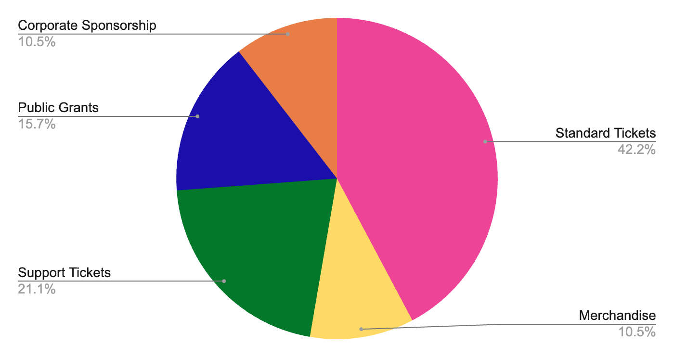
The anticipated expenditure amounts to $86,000, with venue rental and equipment expenditures constituting $54,000 as the principal expense category. Additional expenditures encompass staffing ($8,000), advertising and marketing ($4,000), special events and guest honoraria ($4,000), administration ($3,000), accessibility tools ($6,000), and film licensing (about $9,000). Licensing includes a varied array of programs: classic musicals such as The Sound of Music and Les Misérables, animated successes like Frozen and The Lion King, independent art documentaries such as Dusk Chorus and Imagine, and works by visually impaired or local filmmakers, exemplified by I’m Only Blind (2025). De Valck (2016, p.106) contends that symbolic capital obtained from festival selection and accolades can be converted into economic capital. This relationship is significant, as renowned productions like Hamilton demonstrate how festival programming legitimizes films as both cultural treasures and economically viable commodities.
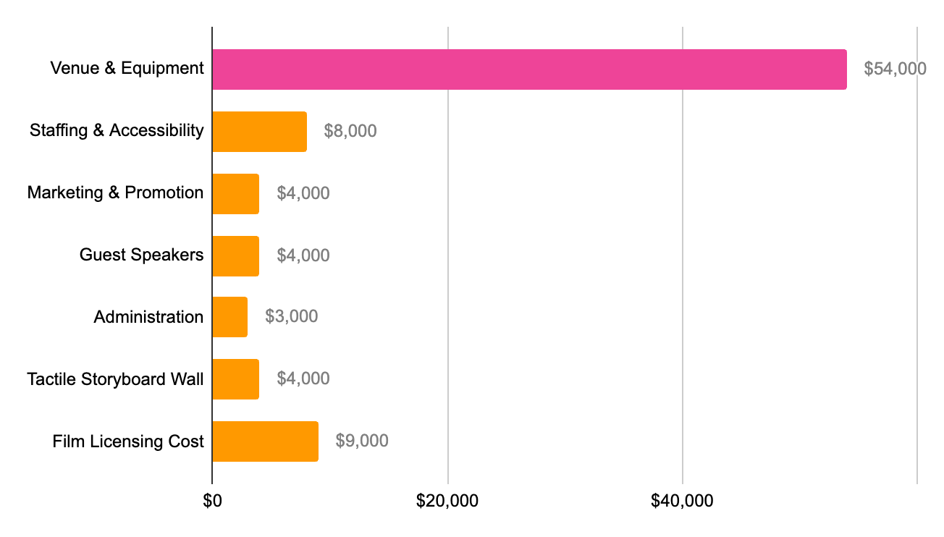
The festival remains financially viable, with ticket sales covering most costs and external support ensuring sustainability. With a projected surplus of $9,480 to accessible projects, this exemplifies an economically viable and socially responsible model that harmonizes cultural authenticity with economic sustainability.

Audience (who is the target audience and where is the festival set)
The SEE Film Festival is designed primarily for young adult to senior audiences, as some films feature mature or complex themes, and these age groups may gain the most from the Q&As, talks and exhibits. The festival takes place in October to coincide with Blindness Awareness Month, a time dedicated to highlighting the daily challenges faced by blind and visually impaired communities, raising public awareness, and advocating for accessibility and research. We felt that hosting the festival during this month strengthens its purpose: to create an inclusive cinematic experience where people with visual impairments feel acknowledged and represented.
With audio description, music-centred films, and a strong focus on sound, our goal is to ensure that blind and low-vision audiences feel truly included in the film festival space. But at the same time, the SEE Film Festival is not exclusive. All films screened keep their full high-quality visuals for sighted audiences, and exhibits and promotional materials are provided in both Braille and written English. We warmly welcome everyone, whether to support friends or family, contribute to a social cause, or simply to reimagine cinema in a new light.
Both blind and sighted audiences are vital to the festival for they help foster a space that is inclusive and educational, offers all audiences the chance to step into a perspective, and brings attention to the daily challenges faced by the blind and visually impaired community.

Special events (extra events planned and why they are significant)
Beyond its carefully curated 16 films, the SEE Film Festival stands out through a series of special events, aiming to deepen audience engagement and highlight the unique perspectives of the blind and visually impaired. These activities go beyond traditional screenings, creating interactive and participatory experiences that align with the festival's broader mission of accessibility, inclusivity, and cultural transformation.
One of the most notable highlights of the film festival is the Immersive Sound Film sessions held during the festival's opening days. These events shift the focus from visual effects to allowing the audience to experience films primarily through sound. This approach not only enhances accessibility for blind viewers but also encourages sighted participants to engage with films in a completely different way, thereby fostering empathy and deepening appreciation for audio storytelling.
The Open Day also features a Q&A session with blind filmmakers, providing a rare platform for directors and creators with blind life experiences to share their artistic journeys. These conversations are not just post-screening discussions; they offer audiences the opportunity to challenge stereotypes, ask questions, and learn directly from filmmakers who are redefining the boundaries of visual culture. Additionally, a guest lecture by renowned blind filmmaker and advocate Gough will further explore the intersection of disability, creativity, and industry change.
During the film festival, various special events kept emerging, including sensory exhibitions and installations, such as "Sensory Storyboards". These tactile experiences allow participants to engage in the film narrative through touch, emphasizing that films can be appreciated through multiple senses. Another participatory element is "Record Your Sound Story", which invites participants to create a 60-second audio piece. This activity gives everyone - whether blind or visually impaired - the opportunity to express creativity, making story-telling more democratic and reinforcing the vision of the festival's inclusive cultural participation.
As De Valc（2012）has argued, film festivals are not merely sites for film exhibition, but function as cultural mediators, creating alternative viewing contexts through programming, curation, and specific screening environments. The SEE Film Festival’s special events ranging from immersive sound sessions to sensory storyboards, precisely illustrate this mediating role. By reconfiguring how audiences engage with cinema, these activities distinguish the festival from commercial theatres and reaffirm its identity as a socially engaged and inclusive cultural platform.

Technical section (logistics, planning and operations)
The main idea behind the SEE Festival is that everyone should be able to get to it. It makes sure that everyone who comes, no matter what their physical or sensory needs are, can enjoy the event. To reach this goal, we offer a wide range of services and devices that help with both mobility and sensory access.

We selected ACMI Cinemas as our venue due to its excellent transport links and accessible facilities. There are tactile floor signs and guiding strips at the venue. These give blind and low-vision people the confidence and freedom to get around. We also offer mobility aids to people who need help getting around. We offer audio guide systems that narrate in real time. These systems make sure that all guests stay connected with the artistic and cultural parts of the program by giving blind and low-vision people clear descriptions of screenings and exhibitions. We also have guides in Braille. These guides make important program information easy to find. We also have volunteers who have been trained in accessibility. They are always there to offer advice, help, and comfort. They make the space feel welcoming and comfortable. Along with well-known backup plans, we also offer full medical and safety support.

The festival also wants to change how people feel and enjoy movies. We do this by adding new and interesting experiences that engage all of the senses. The Tactile Storyboard Wall is one of the most important parts. Through textured reliefs and sculpted forms, this installation lets people "feel" famous scenes from movie history. This wall that you can touch and talk to is a new way to tell stories. It lets people who are blind, have low vision, or can see all imagine how they fit into visual culture.

Marketing (promotional aspects of festival e.g advertising and public relations)
The marketing strategy for the 2026 SEE Film Festival prioritises accessibility and cultural innovation. Designed specifically for blind and low-vision audiences, the campaign challenges the visual bias of mainstream cinematic events by centring non-visual sensory experiences and inclusive design across all platforms. Preliminary analysis of Melbourne’s festival market identified a clear gap in offerings that meaningfully engage blind and low-vision participants. Many cultural events continue to prioritise visual spectacle in both programming and promotion, limiting access for audiences with alternate sensory preferences. Feedback gathered from the Blind Cinema project and Vision Australia’s community forums further confirmed the need for a public-facing platform that values sensorial diversity and narrative accessibility.
A braille-accessible brochure was co-designed with Braille House, featuring Grade 1 Braille, high-contrast text, and a tactile cover layout that signals inclusivity and empathy. These brochures are distributed through libraries, Vision Australia branches, and local community centres. In addition to serving blind audiences, the design communicates the festival’s accessibility ethos to sighted attendees, reinforcing the brand's commitment to inclusive participation.
Based on the research, the digital campaign revolves around the tagline “To listen closely, to feel deeply, and to see cinema differently.” Content is tailored to accessibility standards across platforms: Instagram posts include alternative text; Facebook events are screen-reader compatible; TikTok and YouTube videos contain full captions. Messaging spotlights audio-led programming, tactile art installations, and blind-led film content, cultivating an audience across both the disability arts sector and the broader public.
We will also select social media influencers, particularly those focused on disability justice and accessible art, who were invited to participate in the campaign to increase its reach and authenticity. This strategy aligns with the evolving role of niche film festivals, which have expanded beyond community spaces to become important platforms for circulating underrepresented themes, stories, and creators across broader cultural networks (Loist, 2016, pp. 56–57).
All media outreach prioritises audio-first channels, including Vision Australia Radio and community podcasts. The choice of radio, beyond accessibility, symbolises the festival’s embrace of sound as cinema’s primary medium. Press kits were adapted for screen readers, and media previews included excerpts from audio-described films to allow journalists to experience the programming approach firsthand.

Conclusion
Overall, the SEE Film Festival demonstrates that accessibility and artistic innovation are not mutually exclusive, but fundamentally interconnected. By centring the experiences of blind and low-vision audiences, the festival redefines the role and meaning of a film event. From sound-led screenings and tactile installations to accessible marketing and ticketing models, every element of the SEE Festival is designed to challenge ableist norms in the cultural sector. Its mixed-audience approach invites both blind and sighted participants to engage with cinema on equal terms—fostering empathy, raising awareness, and sharing joy. As a sustainable, not-for-profit initiative with a clear social mission, the SEE Film Festival offers more than entertainment: it serves as a blueprint for inclusive cultural participation. In doing so, it contributes meaningfully to broader conversations about equity in the arts and affirms that, at its best, cinema truly belongs to everyone.
References
De Valck, M. (2016) ‘Fostering art, adding value, cultivating taste: Film festivals as sites of cultural legitimization’, in de Valck, M., Kredell, B. and Loist, S. (eds.) Film Festivals: History, Theory, Method, Practice. New York: Routledge, pp. 100–116. doi: 10.4324/9781315637167.
Marijke de Valck (2012) Finding Audiences for Films: Festival Programming in Historical Perspectives. In: Coming soon to a festival near you: programming film festivals. St Andrews, Scotland, United Kingdom, St Andrews Film Studies. pp. 25–40.
Fischer, A. (2013). Open for business: The system behind film festival operation. In D. Iordanova & L. Torchin (Eds.), Sustainable Projections: Concepts in Film Festival Management (pp. 15–27). St Andrews: St Andrews Film Studies.
Kakol R. (2021). I’m blind, but I love going to the movies. Here’s how it works. ABC News. [online] 9 Jan. Available at: https://www.abc.net.au/news/2021-01-10/blind-disability-but-i-love-the-movies-film/12958854 [Accessed 7 Sep. 2025].
Loist, S. (2016) The film festival circuit: Networks, Hierarchies and Circulation. In: B. Kredell, S. Loist, & M. de Valck (eds.). Film festivals : history, theory, method, practice . London ; New York :; London ; New York :, Routledge. pp. 49–64. https://ebookcentral.proquest.com/lib/monash/reader.action?docID=4426549&ppg=68.
National Today. (2020). Blindness Awareness Month. [online] Available at: https://nationaltoday.com/blindness-awareness-month/ [Accessed 9 Sep. 2025]

