Portfolio Proposal:Deaf Music Festival in Melbroune - A Sensory Music Experience for the Deaf and Hard of Hearing
The Deaf Music Festival (DMF) is an innovative reimagining of music festivals that allows everyone to feel the energy and excitement of live music, regardless of hearing. In Australia, deaf art is one of the most underrepresented areas of disability, and deaf music as part of the arts suffers from the same dilemma (Missingham and Hadley 2022:310), so a powerful movement is needed to build a more inclusive cultural landscape that emphasizes community connections that go beyond basic accessibility. According to Gaupp (2020:128), festival curators act as gatekeepers, often defining what is "legitimate" in art and culture. The hosting of the DMF will play an important role by positioning itself as an advocate for inclusivity, with music festivals often abiding by established norms and favoring audience-centric classics to the exclusion of other modes of expression and communication that the DMF aims to address key gaps.
It’s worth noting that according to Get Skilled Access (2024), more than one in six Australians suffering from some degree of hearing loss, the importance of accessibility in music and cultural activities cannot be overstated. Recent research, including the Music Society of Victoria's 2023 Accessible Music Venues Report and Audience Outlook Monitor, identifies a number of barriers faced by audiences, ranging from physical and communication challenges to social and economic barriers. These findings highlight a gap in the cultural economy, where existing activities often exclude those who could benefit most from inclusive design. DMF has responded to this need by introducing a music festival that caters to a wide range of sensory experiences, transforming music into a shared, multi-dimensional art form (Get Skilled Access 2024).
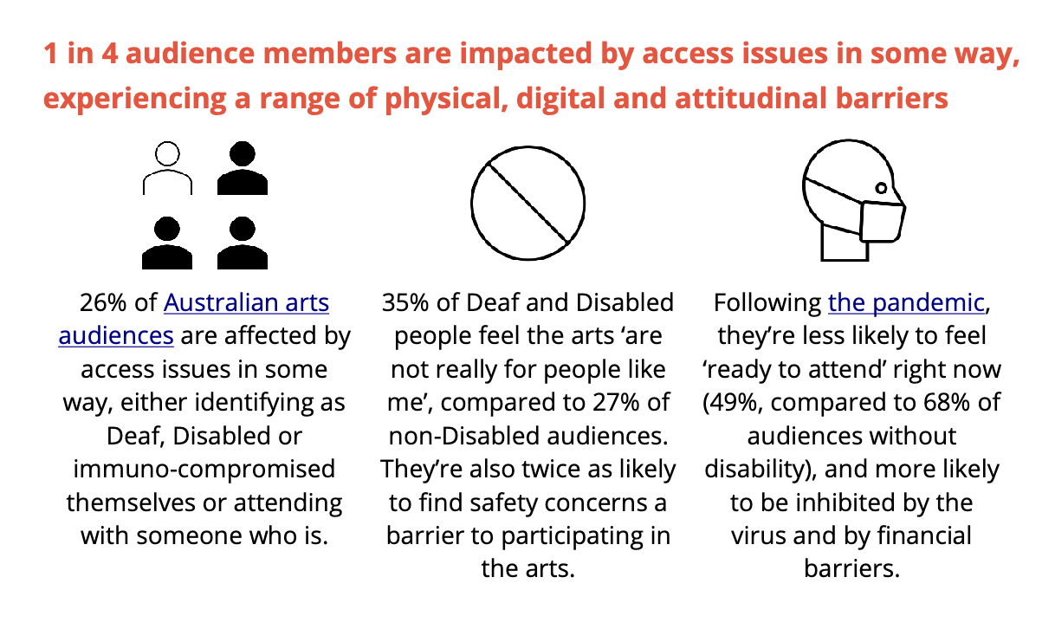
Figure 1：Image taken from A report on the City of Melbourne and City of Yarra Accessible Music Venues project. (page 8) https://app.immersivetranslate.com/pdf/
Accessibility features that support cultural activities can also generate significant economic and social cultrual returns. The World Health Organization reports that every dollar invested in hearing care can yield a return of up to $16, highlighting the value of inclusive initiatives (Get Skilled Access 2024). Music is a universal language, and DMF embraces this by providing attendees with multiple ways to connect through visual presentations, tactile experiences, vibrations, and even dance.
Historically, the habitual default of the public is that music can only be accessed by people who are able to hear it. However, the enjoyment of music does not depend solely on hearing ability, it can be felt by the deaf community through visual and kinesthetic senses (Rebecca 2024). DMF breaks with this tradition and establishes a model in which sensory diversity and inclusion are at the heart of the music festival experience. By providing multi-sensory programs that enable people to interact with music in fresh, innovative ways, DMF addresses an important need in Australia's cultural economy and sets a new benchmark for inclusion in the arts.
Programs
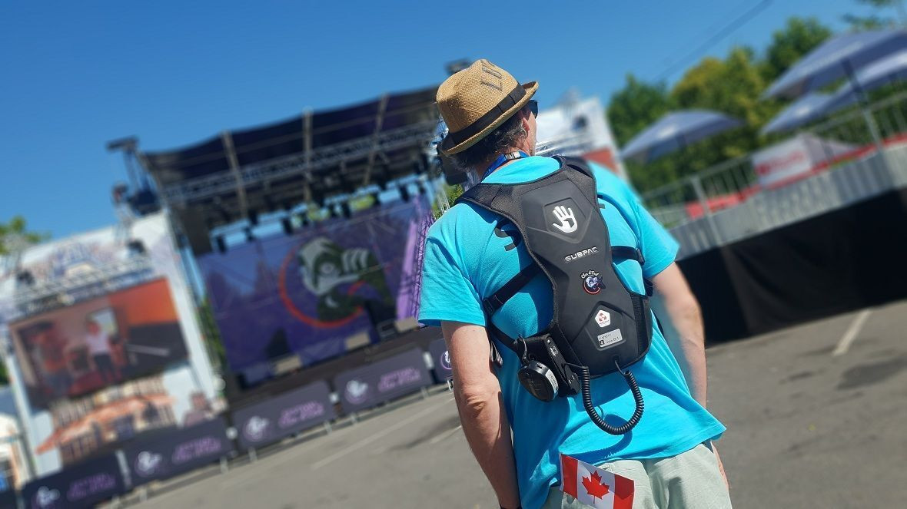
Figure 2: Deaf people wearing subpac vests at the International Festival of Arts in Sign Language
https://www.timmpi.com/on-a-teste-le-subpac-le-sac-a-dos-pour-profiter-dun-concert-quand-on-est-sourd-propose-par-le-festival-clin-doeil/
- Vibration Experience Areas: These areas, set up at various locations within Her Majesty's Theatre, will be equipped with wearable SubPac vests and vibration platforms that will allow attendees to feel the beat and rhythm of the music through vibrations. Subpac is a wearable bass responsive amplifier and speaker system that allows deaf people to feel the bass and shape it more accurately (Musicradar 2022). There are 24 touch points on these wearables, which can be synchronized with the instrument to vibrate with different instruments in the music (Alex 2023). Each vibration zone will highlight different genres, including rock, electronic and jazz, offering a diverse vibrational experience that allows participants to connect with the pulse of the music without relying on sound (Aker et al. 2022:3396).
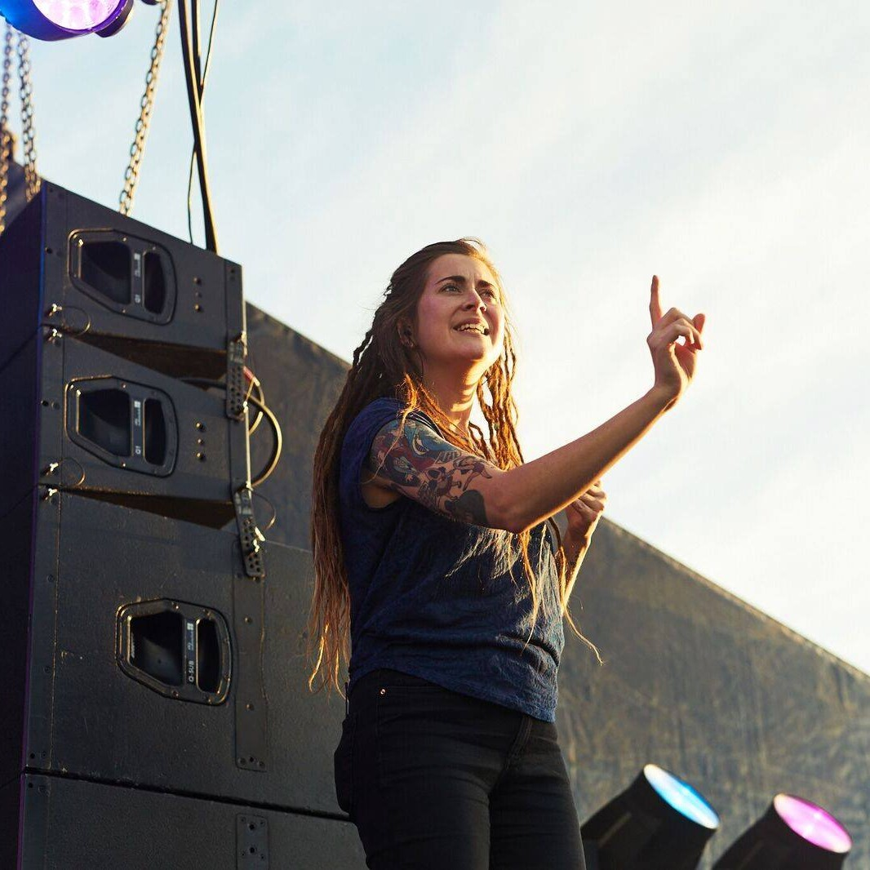
Figure 3：Example of sign language music performances at DMF. https://getskilledaccess.com.au/blog/auslan-interpretation-revolutionising-live-music-accessibility-in-australia/
- Sign language interpretation music performance：Sign language music performances, mainly for deaf audiences, focus on enhancing visual and emotional expression, allowing the audience to feel the music more deeply through sign language, lighting and multimedia (Rebecca 2024). DMF will select emotional and rhythmic music, and sign language performers will convey emotions through exaggerated facial expressions and body movements. In stage design, with the change of music mood, lighting and multimedia effects to render emotional climax, such as the use of animation or projection to enhance the mood of the lyrics. Visual elements can strengthen the atmosphere of sign language expression, so that the audience can be immersed in the emotional world of music, even if they cannot hear the melody, they can deeply feel the shock and emotional depth of music (SCHMITT 2017:137).
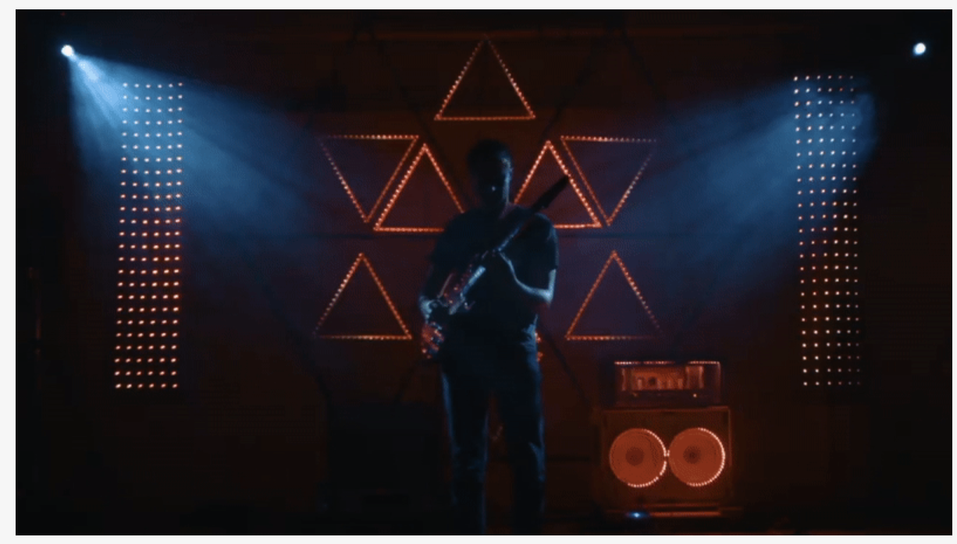
Figure 4: Example for audiolux performance.https://www.cymaspace.org/audiolux/
- Interactive art installation exhibition: In DMF's interactive art installation exhibition, an Audiolux experience area designed for deaf audiences can be set up to create an immersive interactive art installation with "visual sound" as the core. The Audiolux system, developed by the CymaSpace team, is dedicated to making the performing arts more inclusive and accessible, allowing deaf audiences to "see" music by transforming sound into visual elements (CYMA Space 2024).
The Audiolux system presents the rhythm and emotion of music through multi-dimensional light effects, colors and vibrations, transforming audio input into rich visual effects in real time to form a "visual sound" experience. Reflect the rhythm and emotion of the music through changing shapes, light or colors. This design allows the tactile and visual elements of the music to emerge, allowing attendees to interact with the music through sight and touch. Visitors observe the rhythmic effect of the color and lighting as the music changes. These interactive installations not only provide deaf people with the opportunity to interact with the festival content, but also provide all audiences with an immersive art form that differs from the traditional experience, making the festival a truly inclusive, multi-sensory cultural experience.
Scope and scale
- Location and venue: The DMF will be held at Her Majesty's Theatre in Melbourne, a historic and accessible venue that offers a more intimate and focused experience while providing the infrastructure needed to support multi-sensory functionality (Her Majesty's Theatre 2024). The layout of the theatre is ideal for controlled immersive installations and its location in the heart of Melbourne ensures accessibility and convenience.
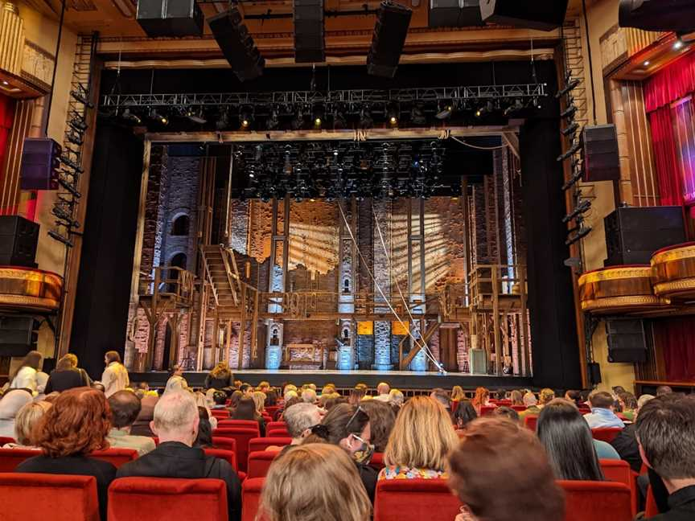
Figure 5: Her Majesty's Theatre stage
https://localista.com.au/listing/her-majestys-theatre?place=melbourne+cbd-suburb%2C+vic%2C+au
- Event size and Duration: DMF is designed as a two-day festival with 45 minutes of musical performances and interaction in two different periods each day, with a capacity of up to 1,700 attendees per day. The duration of the music festival is taken into account that according to Reynolds and VanWeelden (2024:44), the music festival for the deaf can be shortened to reduce the sensory burden because it avoids sudden high volume and rapid rhythm changes. This scale ensures that the experience remains personalised and accessible to all participants, with staff help available as needed.
- Comparison with existing CEEF: DMF differentiates itself from traditional music festivals by focusing on sensory accessibility and inclusion. While mainstream music festivals rely primarily on sound, DMF has pioneered an inclusive, multi-sensory approach to music enjoyment, establishing a new model for accessible music festivals within the cultural economy (Rebecca 2024).
People &Stakeholders and support
DMF aims to be a culturally inclusive event that brings together a wide range of audiences, including deaf, deaf-blind, hearing-impaired people and their Allies in the wider community. The festival targets both primary and secondary audiences who share a common interest in accessibility and inclusion in music and art.
Key Audiences: DMF's key audiences include deaf, deaf-blind and hearing-impaired communities across Australia. By hosting a music festival that offers a variety of sensory experiences, DMF is directly serving these communities, creating a space where they can fully participate in music in a way they never had before. This approach is particularly resonant among young people and adults who actively seek out accessible cultural experiences and often face restrictions in traditional festival environments.
Secondary Audience: This group includes family members, friends, educators, advocates, and other Allies who support inclusion. They play an important role in fostering a sense of solidarity and promoting a wider understanding of deaf culture. In addition, individuals who do not have hearing impairments but are interested in unique multi-sensory cultural activities are encouraged to participate, which helps break down barriers between hearing and non-hearing communities.
To reach and engage these communities, DMF will partner with Deaf Connect, Deaf Victoria and Deaf Australia. Each of these organizations plays a vital role in advocating for the rights and needs of deaf and hard of hearing people, and their participation ensures that DMF productions are made with insight, sensitivity, and respect for the cultural values and history of the community (Deaf connect 2024). By partnering with these organizations, DMF will be able to create a fully accessible, culturally respectful event that amplifies the voices and experiences of the deaf community while promoting inclusive practices to the broader public.
Expected return on investment for stakeholders:
- Social Impact: For organisations such as Deaf Connect, Deaf Victoria and Deaf Australia, DMF represents a high-impact event that aligns directly with their mission to promote accessibility, build community capacity and create social change. The festival provides a platform for them to advocate for inclusive practices while showcasing the deaf community's culture and contributions to the arts (Deaf Victoria 2024).
- Public and cultural recognition: The Melbourne Government and supporting organisations will gain public recognition as leaders in accessibility and inclusion. By partnering with DMF, they can demonstrate a commitment to diversity and inclusive growth in the arts, enhancing Melbourne's position as a forward-thinking cultural hub.
Values&impacts
- Audience satisfaction and attendance: Each deaf participant will be invited to fill out a satisfaction questionnaire after the event to measure satisfaction and areas for improvement. In addition, recording the number of people who re-attend different festival performances, attendance and re-attendance rates will provide quantitative insights into the festival's appeal and growth potential (Brown et al. 2015:139).
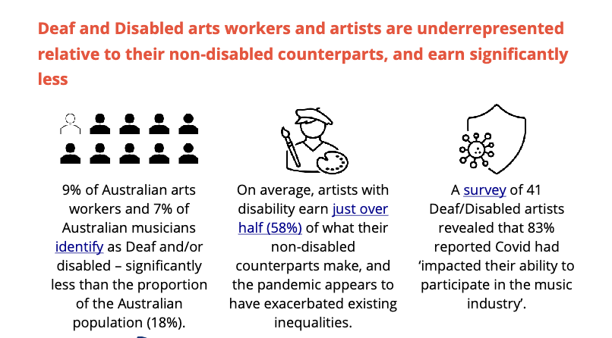
Figure 6：mage taken from A report on the City of Melbourne and City of Yarra Accessible Music Venues project. (page 8) https://app.immersivetranslate.com/pdf/
- Bring economic benefits to the deaf community: DMF is expected to have a positive impact on deaf artists' earnings by providing a platform to celebrate their talents and promote industry recognition. By highlighting deaf performers, DMF increases their visibility and opens up new performance and collaboration opportunities, potentially leading to more bookings at other events. In addition, the festival's partnerships with organizations such as Deaf Connect and Deaf Victoria can lead to long-term career opportunities for deaf artists. This exposure not only enriches the cultural economy, but also supports sustainable income growth for deaf performers within the arts industry.
- Social Media Engagement: On the one hand, DMF's online presence will be tracked through metrics such as social media shares, likes, comments, and hashtags. High participation will reflect the public interest and expand the conversation about accessibility and inclusion in the arts. A positive social media response will also expand DMF's reach, reach a wider audience and encourage discussion about the importance of accessible cultural events. On the other hand, media coverage by mainstream news outlets and specialist publications focused on accessibility and the arts would be an important indicator. Positive media attention will help build the DMF's reputation as a pioneering, inclusive event and could inspire similar initiatives in Australia and beyond.
Creative personnel
- Sign language interpreter
Sign language interpreters play an important role in ensuring deaf attendees can participate in the festival in an equal and immersive way. They translate live performances, workshops and announcements into Australian Sign Language (Auslan-ASL), enabling deaf participants to fully understand and enjoy each event session. Interpreters will also facilitate informal interactions and facilitate communication between deaf and hearing attendees, thereby making the DMF a truly multilingual and inclusive space (Claire 2021).
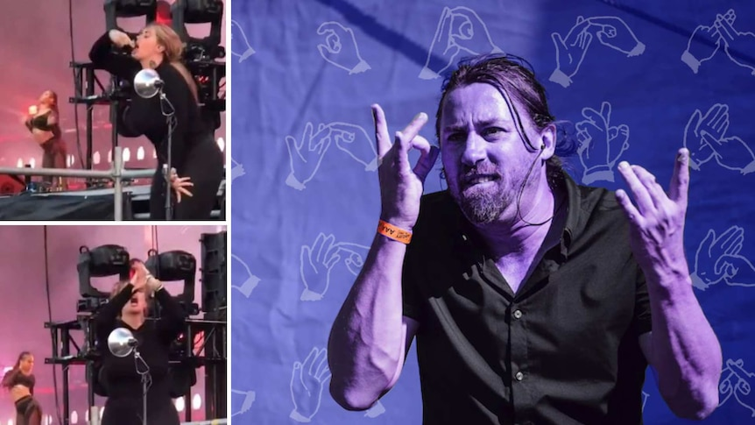
Figure 7: example of qualified Sign language interpreter :'WAP' at Lollapalooza, 2021. Auslan interpreter Mike Webb

2.Sensory Experience Designer
The Sensory Experience designer will lead the development of all sense-driven aspects of the festival, including vibration zones, visual displays and interactive installations. Working closely with sound engineers, lighting technicians and visual artists, this person will ensure that all aspects of the festival are designed to maximize sensory engagement. They will be responsible for translating musical elements into tactile, visual and kinesthetic experiences that are easily accessible and enjoyable for deaf, hard-of-hearing and hearing participants alike.
3.Accessibility Coordinator
The Accessibility Coordinator will ensure that the DMF meets and exceeds all accessibility standards. They will work with Deaf Connect, Deaf Victoria and Deaf Australia to understand specific community needs and implement inclusive design across all festival elements. This includes arranging ASL interpreters, visual AIDS, clear signage, accessible seating, and managing all aspects of sensory and physical accessibility. In addition, the coordinator will train festival staff and volunteers on best practices for serving deaf and hard-of-hearing people.
Challenges and risks
- Purchase tickets and book accessibility facilities
DMF faces specific challenges in ensuring that deaf and hard of hearing people, as well as performers, can successfully complete the ticket purchase and admission process. El (2022) shows that 80% of performers who are deaf or disabled have difficulty accessing live performance venues.
Customers who are deaf and hard of hearing often have difficulty arranging tickets through traditional channels. For some, it is impractical to arrange a visit over the phone, and the rigid online booking system may not meet their accessibility needs. To address this, DMF must prioritize an accessible multi-channel booking system that includes an online portal that is easy to navigate and email support. Clear accessibility information on the festival website will guide deaf participants through the booking process, minimising confusion and ensuring a smooth experience (El 2022).
- Issue of funding for DMF
For smaller music festivals like the DMF, securing sufficient funding to support full accessibility is a major challenge. Unlike large festivals with large budgets and major sponsors, small events often operate with limited financial resources, which can limit the range of accessible services they can offer (Bossey 2020:17).
- Integrate sign language interpretation into a multi-sensory festival environment
DMF faces the challenge of integrating sign language interpretation into a multi-layered performance space. According to Richardson (2018:66), Separating interpreters from the main stage may force deaf attendees to choose between watching an interpreter or a performance, reducing their ability to participate fully. Solutions include integrating interpreters into visually subtle areas on stage, using multiple screens for captioning and ASL interpretation, and adjusting lighting to balance accessibility features with minimal interference. These strategies help ensure a cohesive, inclusive experience that enables deaf and hearing participants to fully participate in the festival.

Rreference
Aker SC, Innes-Brown H, Faulkner KF, Vatti M and Marozeau J (2022) ‘Effect of audio-tactile congruence on vibrotactile music enhancement’, The Journal of the Acoustical Society of America, 152(6):3396–3409, doi:10.1121/10.0016444.

Alex Hughes (2023) These vibrating vests bring music to life for deaf gig-goers, BBC Science Focus, accessed 30 October 2024.
https://www.sciencefocus.com/future-technology/these-vibrating-vests-bring-music-to-life-for-deaf-gig-goers

Bossey A (2020) ‘Accessibility all areas? UK live music industry perceptions of current practice and Information and Communication Technology improvements to accessibility for music festival attendees who are deaf or disabled’, International journal of event and festival management, 11(1):6–25, doi:10.1108/IJEFM-03-2019-0022.

Brown S, Getz D, Pettersson R and Wallstam M (2015) ‘Event evaluation: definitions, concepts and a state of the art review’, International journal of event and festival management, 6(2):135–157, doi:10.1108/IJEFM-03-2015-0014.

Claire Bracken (2021) Sign language interpreter on the art of signing at music festivals, triple J, accessed 30 October 2024.
https://www.abc.net.au/triplej/the-latest/sign-language-interpreter-music-festival-wap-lollapalooza-auslan/13486814

CYMA Space (2024) Audiolux: A Modern “Visual Sound” System for Deaf & Hard-of-Hearing, CYMA Space, accessed 30 October 2024.
https://www.cymaspace.org/audiolux/

Deaf Australia (2024) About Deaf Australia, Deaf Australia, accessed 30 October 2024.
https://deafaustralia.org.au/about-deaf-australia/

Deaf connect (2024) About us, Deaf connect, accessed 30 October 2024.
https://deafconnect.org.au/about-us

Deaf Victoria (2024) About us, Deaf Victoria, accessed 30 October 2024.
https://www.deafvictoria.org.au/about-us/

El hunt (2022) Access All Areas: Making space for Deaf and hearing impaired music fans Access All Areas, PRS for Music, accessed 30 October 2024.
https://www.prsformusic.com/m-magazine/features/access-all-areas-making-space-for-deaf-and-hearing-impaired-music-fans

Gaupp L (2020) ‘The “West” versus “the Rest”? Festival Curators as Gatekeepers for Sociocultural Diversity’, in Managing Culture, Springer International Publishing, Cham, doi:10.1007/978-3-030-24646-4_6.

Get Skilled Access (2024) The Auslan Revolution: Transforming Live Music Accessibility in Australia, Get Skilled Access, accessed 30 October 2024.
https://getskilledaccess.com.au/blog/auslan-interpretation-revolutionising-live-music-accessibility-in-australia/

Her Majesty's Theatre (2024) Her Majesty's Theatre history, Her Majesty's Theatre, accessed 30 October 2024.
https://hmt.com.au/our-history/

Missingham R and Hadley B (2022) ‘Oppression and allyship in Australia’s deaf arts’, Australasian drama studies, (80):304–332.

Oliver Payne (2022) Coldplay are giving Subpacs to deaf and hard of hearing fans at live shows, Musictech, accessed 30 October 2024.
https://musictech.com/news/events/coldplay-are-giving-subpacs-to-deaf-and-hard-of-hearing-fans-at-live-shows/

Rebecca A Withey (2024) Rebecca A Withey: The growing acceptance for music within the deaf community (BSL), The Limping Chicken, accessed 30 October 2024.
https://limpingchicken.com/2024/05/02/rebecca-a-withey-the-growing-acceptance-for-music-within-the-deaf-community/

Reynolds JH and VanWeelden K (2024) ‘Tips for Making Music Performances Sensory-Friendly and Inclusive’, Journal of General Music Education, 37(2):43–46, doi:10.1177/27527646231211704.

Richardson M (2018) ‘The Sign Language Interpreted Performance: A Failure of Access Provision for Deaf Spectators’, Theatre topics, 28(1):63–74, doi:10.1353/tt.2018.0009.

SCHMITT P (2017) ‘Representations of Sign Language, Deaf People, and Interpreters in the Arts and the Media’, Sign language studies, 18(1):130–147, doi:10.1353/sls.2017.0023.

